Analysis of HMF data from the Juno Spacecraft

This project aims to analyse data from the Juno Spacecraft to measure changes in the Heliospheric Magnetic Field (HMF) between 2011 and 2016. The data used is in the form of the magnetic vectors, measured between 1 and 5 AU from the Sun.

The main focus will be on the time and variation in radial distance from the Sun. Data from the ecliptic plane will be considered meaning the HMF can be approximated to be solely a function of distance from the Sun and time. An additional approximation assumes the radial component of HMF is proportional to the inverse square of the distance. Data from different locations can therefore be compared by multiplying each result by its square distance from the Sun, R2.

The first task will generate plots of the variation in the radial component of the HMF ∙ R2 as a function of time, in units of decimal day. The radial component of the magnitude is already predefined in the data as the x component. Preliminary results can be seen in the Figure 1.

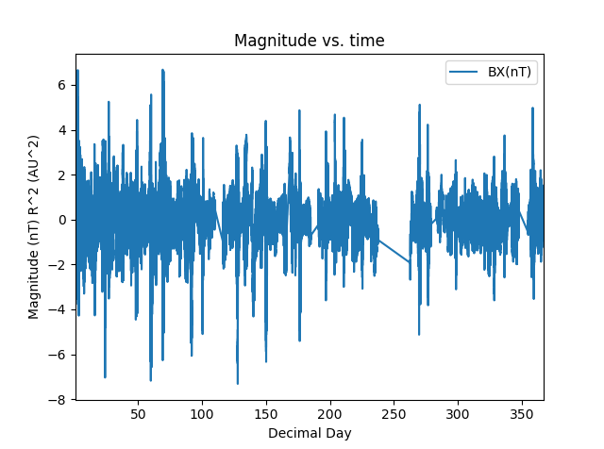

Figure 1: The gaps in data need to be identified. An approach currently considered is substituting NAN values for missing data. Magnitude here is the radial magnitude.

The next task will be to get data from the ACE spacecraft over the same time period. Overlaying the data with the Juno plot will verify the time variation in radial component. It is expected they should be similar.

Juno travelled from Earth to Jupiter and so covered the same radial distance range as Ulysses. Comparing this data should give some indication of the radial decrease in magnitude. The hypothesis of a long-term decrease in the HMF can be tested to see if there has been a significant decrease in Solar activity since Ulysses started recording data in 1990.

A final test will be to take daily and hourly averages of the HMF. This will provide an analysis of small changes in the HMF. A timescale of period of solar rotation, around 27 days, will provide evidence for the effect of Solar rotation on the HMF.

The data will be compared to previous results in literature to verify if the results are in line with current theories on the HMF. This includes using the paper of E. Smith and A. Balough [1] which compared the data from the Ulysses and IMP-8 spacecrafts to verify the time variations in the Radial Field components.

[1] Smith, Edward J. and Balogh, A, *Ulysses observations of the radial magnetic field*, 1995.